

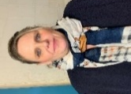
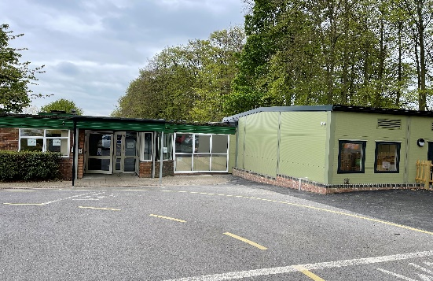
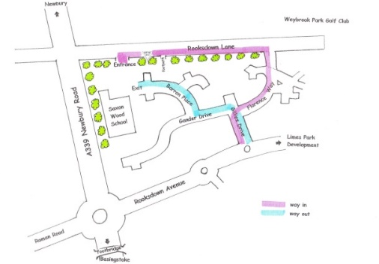
S
Staff Conduct
If you are concerned about the conduct of a member of staff, following an observation or disclosure, the following actions must be taken:
- Immediately inform the Head Teacher
- In their absence, immediately inform on of our Assistant Head Teachers.
- If you have a concern about the conduct of the Head Teacher inform the school’s Chair of Governors.
Our Safeguarding Team
Our Designated Safeguarding Lead (DSL) is
Mrs Jakki Alexander
(Head Teacher)

Our Deputy Designated Safeguarding Leads (DDSL) are

Mrs Hannah Hyatt
(Assistant Head Teacher)

Mrs Amy Wheeler
(School Business Manager)

Saxon Wood School

Safeguarding Information
for
School Visitors and Volunteers
Welcome to Saxon Wood School
We are committed to safeguarding and promoting the welfare of children. As such we expect all staff, volunteers and visitors to share this common commitment.
This leaflet contains information about our expectations of you whilst visiting the school. It gives information about our Safeguarding Procedures and all visitors and volunteers are required to sign that they have read the contents, understood and will adhere to the information on this sheet.

Saxon Wood School
Barron Place
Basingstoke
RG24 9NH
Tel: 01256 356635
www.saxonwood.hants.sch.uk
I
Our regular volunteers, staff and governors have a valid DBS check.
If you feel that a child may be as risk of harm but are not sure, then inform the DSL or one of our Deputy DSLs. They will offer advice and take appropriate action.
Child abuse can happen to any child regardless of elements such as gender, culture, religion, social background, ability or disability.
A copy of the schools Safeguarding policy can be obtained from the school office on request.
Types of harm
We all have a responsibility to keep children (under the age of 16) safe, both at home and in school. Harm is identified in four ways:
Physical – when a child is deliberately hurt or injured.
Sexual – when a child is influenced by or forced to take part in sexual activity. This can be a physical activity or non-physical, e.g. being made to look at an inappropriate image.
Emotional – when a child is made to feel frightened, worthless or unloved. It can be by shouting, using threats or making fun of someone. It can also be when children see parents, or visitors to the home, fighting or using violence.
Neglect – when a child is not being taken care of by their parents/guardians. It can be poor hygiene, poor diets, not keeping appointments for additional support, not coming to school or being left home alone.
REMEMBER…if in doubt…ask
Please do not leave our school without telling someone or doing something.
Keeping ourselves safe
- All visitors must sign in at Reception on arrival
- Visitors are asked to read this leaflet in full on arrival on their first visit and will be asked to sign to confirm they have read, understood this and agree to follow the information
- Visitors should remain in reception until advised
- Mobile phones/iPads are not to be used whilst on the school site
- Photographs are not to be taken unless by prior agreement
- Act responsibly at all times
- Report to staff any unacceptable behaviour
- When working with a pupil(s) ensure you are visible to others
- All visitors must sign out at Reception
Regular Volunteers
- Volunteers must sign in at Reception
- Volunteers must sign out at Reception

If a child discloses they might be subject to abuse:
- React calmly
- Listen carefully to the child, particularly what is said spontaneously
- Do not promise confidentiality. Explain to the child that you must pass on information if you are worried about their safety
- Do not ask leading questions or make judgements. Clarify and check your concern if you feel that you are not sure, by using, for example, “tell (T), explain (E) describe (D)” but as soon as you believe that there might be a genuine issue, ask no further questions. This would compromise further enquiries.
Only trained investigators should question a child.
Reassure the child that they are doing the right thing and tell them that you are going to take them to a member of staff that will know what to do.
Take the child to the DSL or one of our Deputy DSLs.
Record carefully, on the concern forms which can be found in the staff room or school office what the child says in their own words including how and when the account was given. This must be dated and signed and immediately passed to the DSL or one of our Deputy DSLs.

