

Low-Level Concerns Policy

Date approved :
October 2025

Date for review: October 2026
(or sooner if required)

1. Introduction
At Saxon Wood School, we take safeguarding very seriously. This includes ensuring that adults who work with children do so in a way that is in accordance with the ethos and policies set out by the school, including the Staff Code of Conduct. This policy sets out the detail and processes for staff regarding low-level concerns they may have.

2. Summary
It may be possible that a member of staff acts in a way that does not cause risk to children, but is however inappropriate. A member of staff who has a concern about another member of staff should inform the Head Teacher about their concern using a Low-Level Record of Concern Form. If the Head Teacher cannot be contacted, the Chair of Governors should be contacted instead.

3. Keeping Children Safe in Education September 2025
The following information has been taken from KCSIE 2025:
- Concerns or allegations that may meet the harm threshold
- Concerns or allegations that do not meet the harm threshold
- Low- level concerns
- What a low- level concern is
- Staff code of conduct and safeguarding policies
- Sharing low-level concerns
- Recording low-level concerns
- References
- Responding to low-level concerns

Concerns or allegations that may meet the harm threshold
This part of the guidance is about managing cases of concerns/allegations that might indicate a person would pose a risk of harm if they continue to work in their present position, or in any capacity with children in a school or college.
In this part (section one) of the guidance reference is made to ‘allegation’ for ease. This part of the guidance should be followed where it is alleged that anyone working in the school or a college that provides education for children under 18 years of age, including supply teachers, volunteers and contractors has:
• behaved in a way that has harmed a child, or may have harmed a child and/or
• possibly committed a criminal offence against or related to a child, and/or
• behaved towards a child or children in a way that indicates he or she may pose a risk of harm to children, and/or
• behaved or may have behaved in a way that indicates they may not be suitable to work with children.
Concerns or allegations that do not meet the harm threshold
427. Governing bodies and proprietors should have policies and processes to deal with any concerns or allegations which do not meet the harm threshold, referred to in this guidance as ‘low-level’ concerns. It is important that schools and colleges have appropriate policies and processes in place to manage and record any such concerns and take appropriate action to safeguard children.

Low-level concerns
428. As part of their whole school or college approach to safeguarding, schools and colleges should ensure that they promote an open and transparent culture in which all concerns about all adults working in or on behalf of the school or college (including supply teachers, volunteers and contractors) are dealt with promptly and appropriately. Creating a culture in which all concerns about adults are shared responsibly and with the right person, recorded and dealt with appropriately, is critical. If implemented correctly, this should:

• enable schools and colleges to identify inappropriate, problematic or concerning behaviour early
minimise the risk of abuse, and
• ensure that adults working in or on behalf of the school or college are clear about professional boundaries and act within these boundaries, and in accordance with the ethos and values of the institution.

What a low-level concern is
430. The term ‘low-level’ concern does not mean that it is insignificant. A low-level concern is any concern – no matter how small, and even if no more than causing a sense of unease or a ‘nagging doubt’ - that an adult working in or on behalf of the school or college may have acted in a way that:
• is inconsistent with the staff code of conduct, including inappropriate conduct outside of work, and
• does not meet the harm threshold or is otherwise not serious enough to consider a referral to the LADO.

Examples of such behaviour could include, but are not limited to:
• being over friendly with children
• having favourites
• taking photographs of children on their mobile phone, contrary to school policy
• engaging with a child on a one-to-one basis in a secluded area or behind a closed door, or
• humiliating children.
431. Such behaviour can exist on a wide spectrum, from the inadvertent or thoughtless, or behaviour that may look to be inappropriate, but might not be in specific circumstances, through to that which is ultimately intended to enable abuse.
432. Low-level concerns may arise in several ways and from a number of sources. For example: suspicion; complaint; or disclosure made by a child, parent
or other adult within or outside of the organisation; or as a result of vetting checks undertaken. 433. It is crucial that all low-level concerns are shared responsibly with the right person and recorded and dealt with appropriately. Ensuring they are dealt with effectively should also protect those working in or on behalf of schools and colleges from becoming the subject of potential false low-level concerns or misunderstandings.

Staff code of conduct and safeguarding policies
434. As good practice governing bodies and proprietors should set out their low-level concerns policy within their staff code of conduct and safeguarding and child protection policies as set out in Part two of this guidance. They should make it clear what a low-level concern is and the importance of sharing low-level concerns, and an explanation of what the purpose of the policy is – i.e., to create and embed a culture of openness, trust and transparency in which the school or college’s values and expected behaviour set out in the staff code of conduct are lived, monitored and reinforced constantly by all staff.
435. As set out in Part two of this guidance, the governing body or proprietor should ensure their staff code of conduct, behaviour policies and safeguarding policies and procedures are implemented effectively and ensure that appropriate action is taken in a timely manner to safeguard children and facilitate a whole school or college approach to dealing with any concerns.
436. Schools and colleges can achieve the purpose of their low-level concerns policy by:
• ensuring their staff are clear about what appropriate behaviour is, and are confident in distinguishing expected and appropriate behaviour from inappropriate, problematic or concerning behaviour, in themselves and others
• empowering staff to share any low-level safeguarding concerns (see below)
• addressing unprofessional behaviour and supporting the individual to correct it at an early stage
• handling and responding to such concerns sensitively and proportionately when they are raised, and
• helping identify any weakness in the school or colleges safeguarding system.

Sharing low-level concerns
437. Schools and colleges should ensure that their low-level concerns policy contains a procedure for sharing confidentially such concerns which is clear, easy to understand and implement. Whether all low-level concerns are shared initially with the DSL (or a nominated person (such as a values champion)), or with the headteacher/principal is a matter for the school or college to decide. If the former, then the DSL should inform the headteacher/principal of all the low-level concerns and in a timely fashion according to the nature of each particular low-level concern. The headteacher/principal should be the ultimate decision maker in respect of all low-level concerns, although it is recognised that depending on the nature of some low-level concerns and/or the role of the DSL in some schools/colleges, the headteacher/principal may wish to consult with the DSL and take a more collaborative decision making approach. 438. Low-level concerns which are shared about supply staff and contractors should be notified to their employers, so that any potential patterns of inappropriate behaviour can be identified.
439. If schools and colleges are in any doubt as to whether the information which has been shared about a member of staff as a low-level concern in fact meets the harm threshold, they should consult with their LADO.
440. Schools and colleges should ensure they create an environment where staff are encouraged and feel confident to self-refer, where, for example, they have found themselves in a situation which could be misinterpreted, might appear compromising to others, and/or on reflection they believe they have behaved in such a way that they consider falls below the expected professional standards.

Recording low-level concerns
441. All low-level concerns should be recorded in writing. The record should include details of the concern, the context in which the concern arose, and action taken. The name of the individual sharing their concerns should also be noted, if the individual wishes to remain anonymous then that should be respected as far as reasonably possible.
442. Schools and colleges can decide where these records are kept, but they must be kept confidential, held securely and comply with the Data Protection Act 2018 and the UK General Data Protection Regulation (UK GDPR).
443. Records should be reviewed so that potential patterns of inappropriate, problematic or concerning behaviour can be identified. Where a pattern of such behaviour is identified, the school or college should decide on a course of action, either through its disciplinary procedures or where a pattern of behaviour moves from a low-level concern to meeting the harm threshold, in which case it should be referred to the LADO (as per Part four, Section one). Consideration should also be given to whether there are wider cultural issues within the school or college that
enabled the behaviour to occur and where appropriate policies could be revised, or extra training delivered to minimise the risk of it happening again. 444. It is for schools and colleges to decide how long they retain such information, but it is recommended that it is retained at least until the individual leaves their employment.

References
445. Part three of this guidance is clear that schools and colleges should only provide substantiated safeguarding concerns/allegations (including a group of low-level concerns about the same individual) that meet the harm threshold in references. Low-level concerns should not be included in references unless they relate to issues which would normally be included in a reference, for example, misconduct or poor performance. It follows that a low-level concern which relates exclusively to safeguarding (and not to misconduct or poor performance) should not be referred to in a reference.

Responding to low-level concerns
446. The school or college low-level concerns policy should set out the procedure for responding to reports of low-level concerns. If the concern has been raised via a third party, the headteacher/principal (or a nominated deputy) should collect as much evidence as possible by speaking:
• directly to the person who raised the concern, unless it has been raised anonymously, and
• to the individual involved and any witnesses.
447. The information collected will help them to categorise the type of behaviour and determine what further action may need to be taken. This information needs to be recorded in writing along with the rationale for their decisions and action taken.
448. A good low-level concerns policy will simply be a reflection and extension of the school or college’s wider staff behaviour policy/code of conduct.
449. More detailed guidance and case studies on low-level concerns can be found in: Developing and implementing a low-level concerns policy: a guide for organisations which work with children (farrer.co.uk).

4. Clarity around Allegation vs Low-Level Concern vs Appropriate Conduct
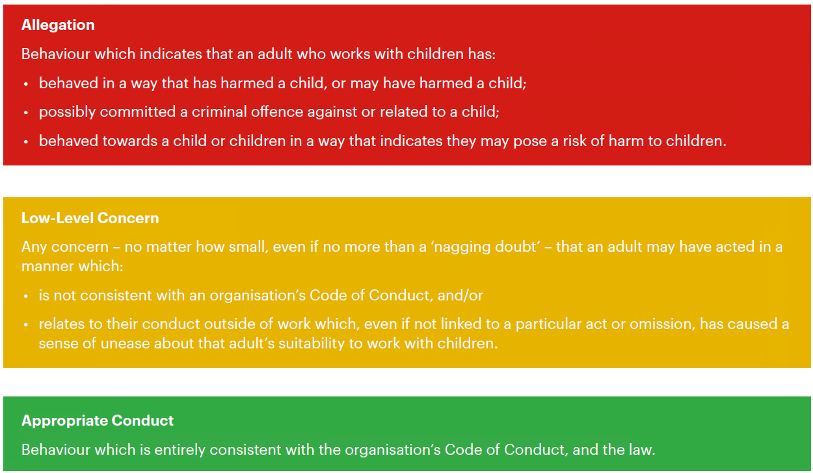

5. Storing and use of Low-Level Concerns and follow-up information
LLC forms and follow-up information will be stored securely within the schools safeguarding systems, with access only by the leadership team. This will be stored in accordance with the school’s GDPR and data protection policies.
The staff member(s) reporting the concern must keep the information confidential and not share the concern with others apart from the Head Teacher or those aware in the senior leadership team.
Low-Level Concerns will not be referred to in references unless they have been formalised into more significant concerns resulting in disciplinary or misconduct procedures.
Whenever staff leave Saxon Wood, any record of low-level concerns which are stored about them will be reviewed as to whether or not that information needs to be kept. Consideration will be given to:
(a) whether some or all of the information contained within any record may have any reasonably likely value in terms of any potential historic employment or abuse claim so as to justify keeping it, in line with normal safeguarding records practice; or
(b) if, on balance, any record is not considered to have any reasonably likely value, still less actionable concern, and ought to be deleted accordingly.

6. Key Reference Document
Read Keeping Children Safe in Education September 2025 Part 4 for further information about Low-Level Concerns.

7. Low Level Concern Form
This form will be available to staff via:
- School network: Teachers – safeguarding – concerns/allegations staff
- The Office
- DSLs
- The Senior Leadership Team

Low – Level Record of Concern regarding a staff member

Please use this form to share any concerns – no matter how small, and even if no more than a ‘nagging doubt’ – that adult may have acted in a manner which:
- Is not consistent with Saxon Wood’s code of conduct and /or
- Relates to their conduct outside work which, even if not linked to a particular act or omission, have caused a sense of unease about that person’s suitability to work with children.
Where possible, speak with the Head teacher as soon as possible. It is also helpful to document your concerns, which can be done using this form and then passed onto the Head Teacher.
If the concern is about the Head Teacher, please pass it onto the Chair of Governors, Alan Rowden
Email is : a.rowden@saxonwood.hants.sch.uk
Remember, a low level concern is different to an allegation (which uses a different form)

